# Issuing cash to different parties in exercise cordapp:

Sending cash to party A:

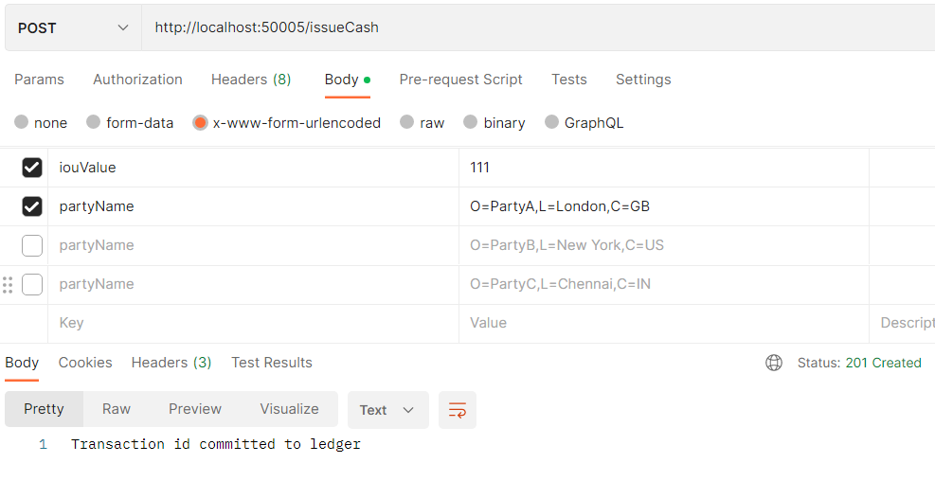

Sending cash to party B:

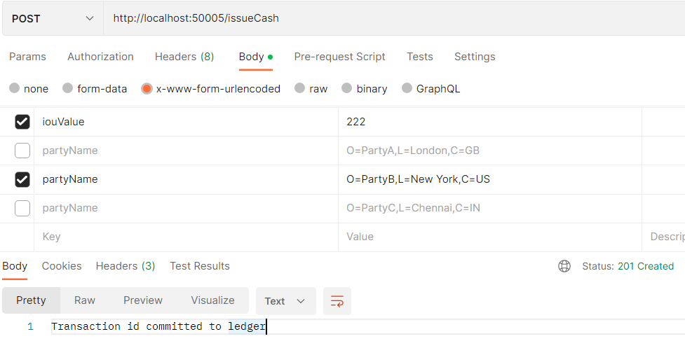

Sending cash to party C:

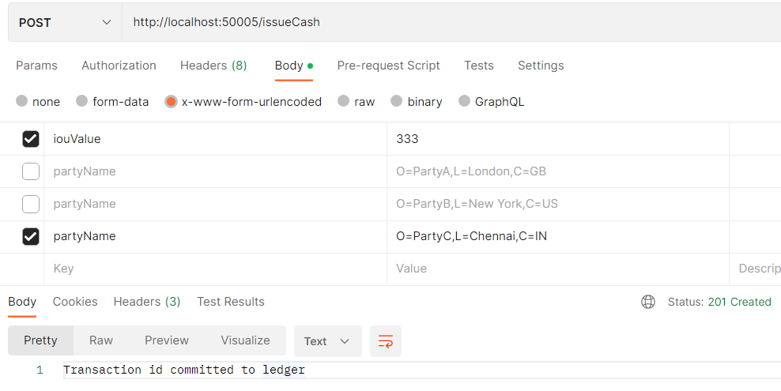

# Checking balance after issuing cash to different parties:

Checking balance of party A:

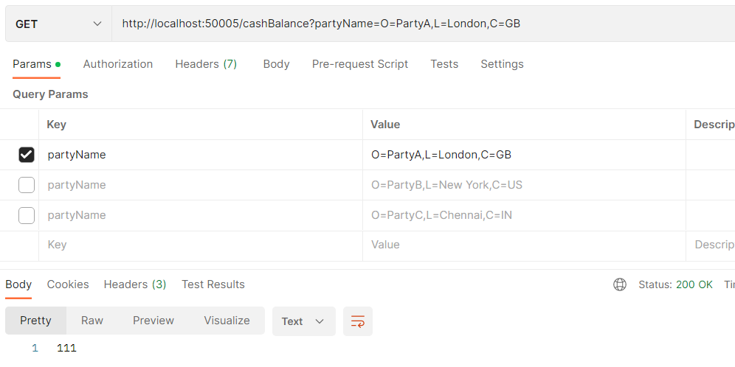

Checking balance of party B:

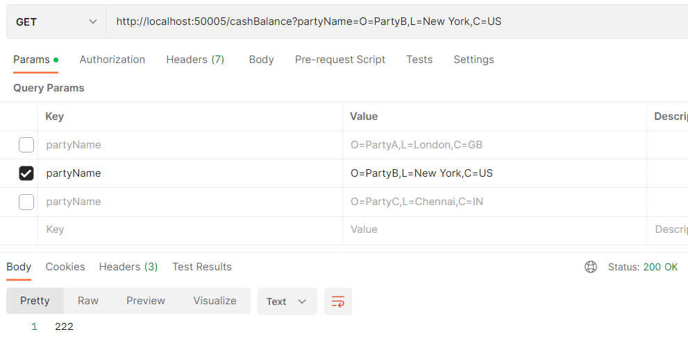

Checking balance of party C:

